 | 

Oregon Department of Transportation

TransInfo Signs Asset Data Integration
Sign Data Access Data Functional Specification

Version 00.2

Bentley Systems 2014

Version Control
Date | Version | Changed by | Notes
November 2014 | 0.01 | JD
Dec 23, 2014 | 0.02 | JD | Sync with CD Dec 22 Draft

Note:
- Version numbers < 1 indicate draft
- Whole numbers indicate a finalized edition
- Version numbers between whole numbers indicate error correction, minor changes altering the substance of the report
- Version numbers with 2 decimal points indicate draft to a minor or major revision.
- Draft changes prior to a major revision should be marked as “DRAFT”
- Version does not indicate acceptance by ODOT or Bentley Systems.

Contents
1. Introduction 4
2. Broker Operations Summary 4
2.1 Broker Installation and Configuration 4
2.2 Connect to Access Sign database 4
2.3 Connect to TransInfo 5
2.4 Collect new or updated Access sign data from sign field app (SFA) 5
2.5 Insert / update Sign Data into TransInfo Sign Asset 6
2.6 Insert / Update SFA Sign and LOV data from TransInfo 8
2.7 Insert / Update Highway 100’s data from TransInfo 10
2.8 Sync Status and Exceptions 10
2.8.1 Sync Status 10
2.8.1 Exceptions 11
3. Sync Process Sign Data Update Logic 11
3.1 Data Model 11
3.2 Installation Data Synchronization Logic 12
3.3 Supports, Maintenance History Synchronization Logic 14
3.4 Panels 15
4. Testing and Data Migration 16
4.1 Testing 16
5. Design Approach 17
6. Development Standards 17
7. TransInfo Data Structures 18
8. Design Assumptions 18
8.1 Foundation Components 18
8.1.1 Asset and Network Data 18
8.1.2 Asset Maintenance Forms 18
8.1.3 Network Maintenance Forms 18
8.1.4 Roles 18
8.2 TransInfo Sync APIs 18
9. Security 19
10. Deliverables 19
10.1 Scripts 19
10.2 Documentation 19
11. Summary 19

Table of Figures

Introduction

- Broker Operations Summary

Broker Installation and Configuration
The Broker software can be downloaded from the Sign SharePoint site and installed via a executable using standard Microsoft processes and UI. Administrative rights may be necessary for installation. Upon first use or connection failure the user is presented with a configuration form, Fig x , which prompts the user for:

- Crew Region ID
- Path to Access db
- Oracle UN/PW
- Oracle data source

Prerequisites: .Net 4.0
Oracle ODP.NET version 4.112.3.0

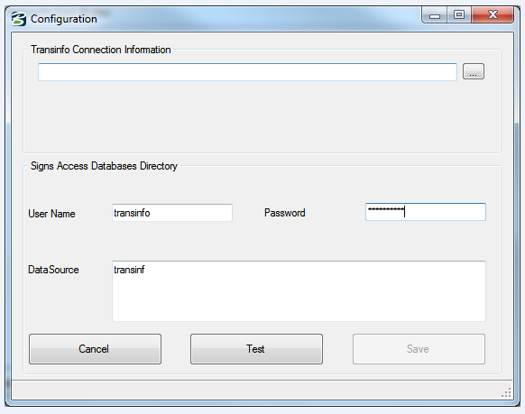

Fig x.

Connect to Access Sign database
This involves the communication protocol required for the Broker to access and open the requisite Access sign tables on the Sign Field (SFA) client computer.

Q. Is the SFA password protected?

Connect to TransInfo
This involves the communication protocol and network access required for the Broker to open the TransInfo Oracle database instance.

Q. Will this require a new user account for each user, or an account for the crew?

  - Collect new or updated Access sign data from sign field app (SFA)

The data collection process reads the Edit tables from SignClient.mdb. This listing is in turn used to request the updated data from the corresponding Sign Inventory tables in signdata.mdb. This process also includes a count of added or updated signs which is used to provide update status feed-back to the user.

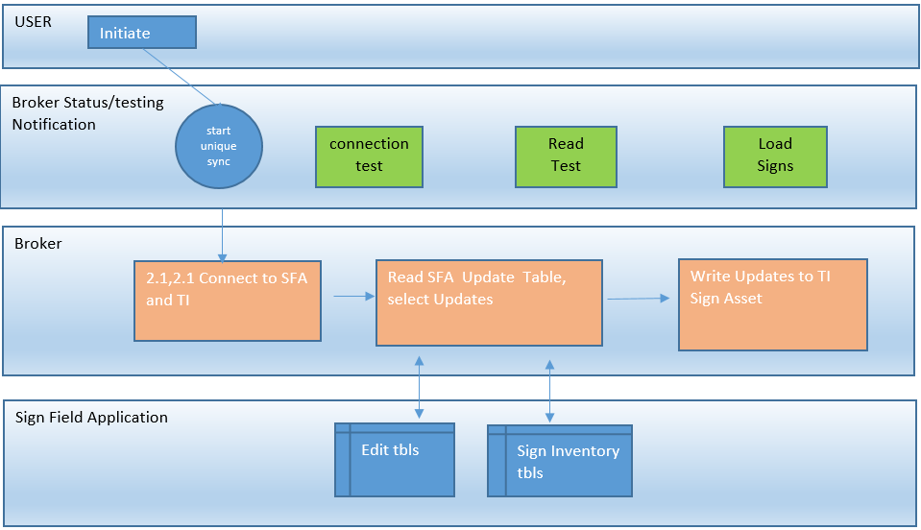

Fig. 1

table has two fieidentifies the installation, Location indicates t is been added o ll other ed ctes

- Installation; this component stores the location of the sign configuration and is considered the parent asset.
- Support; the description of the support type, an Installation has one or more supports
- Standard Signs, as implied these are standard MUCTD sign panels.
- Custom Signs, typically directional signs panels
- Custom Sign Legends, the textual content of the custom sign
- Installation Maintenance History, a record of maintenance activities for a given installation

Table 1. below describes the Edit tables and their corresponding inventory tables.

Edit Tables | Sign Inventory Item tables
tblEditInstallation | tblInstallations
tblEditSupports | tblInstalledSupports
tblEditStandard | tblInstalledStandardSigns
tblEditCustom | tblInstalledCustomSigns
tblEditLegend | tblInstalledSignLegends
tblEditHistory | tblInstallationHistory

The EditInstallation table has two fields: InstallationId and Location. InstallationId identifies the installation, Location is populated when an installation has been deleteddeleted. All other edit tables have one field fldInstalledId.

In the event of an update to any of the SFA sign inventory components SFA populates the edit table with the InstallationID of subject sign inventory component. The field edit process often creates multiple entries for the same installation or installation components (child assets). The broker will only process distinct edit records and therefor does no duplicate the update process for an individual installation or child component.

The data listing obtained from the edit tables is used to generate a request for all new or updated sign data. This data is then inserted or used to update the sign assets in TransInfo, as described in section 2.5.

Insert / update Sign Data into TransInfo Sign Asset

The new or updated sign data collected in the previous step will be inserted in to appropriate asset type. This process, which is described in detail in section 3, processes one asset at a time beginning with the Installation component.

If the update or insert fails, the reason (error message) will be decoded then the rejection error and the asset detail is written to the exception table in TransInfo and the exception listing in the Broker. The Broker then processes the next asset in the edit table listing.

Upon a successful asset load the Broker removes the subject asset installation ID from Edit table and proceeds to the next asset in the edit table listing. This process loops until all assets in the edit tables are processed.

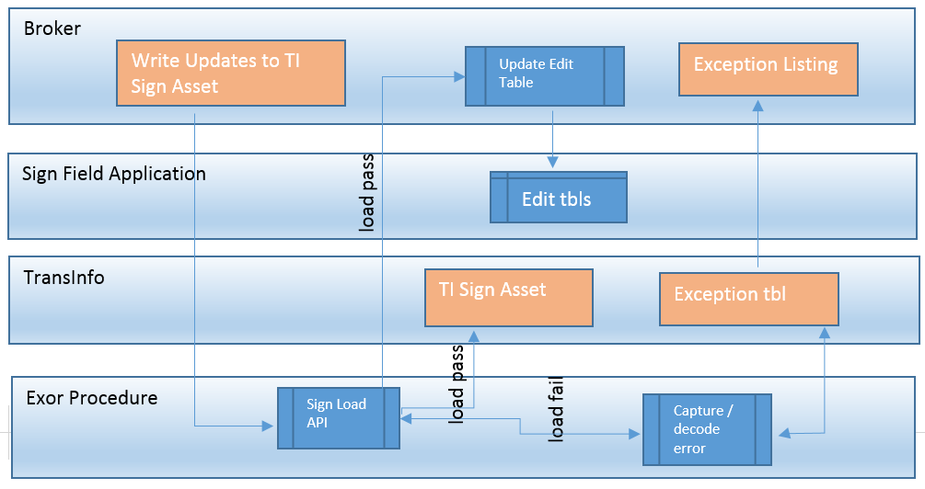

Table 2. The Exception table will include the following fields:

Crew Id
Sync Date
Rejection Description
Installation ID
Component type
Route
Milepoint
Domain UN
Machine Name

The exception table is in essence a running history of all asset rejections for every crew. This table is made available to TIG as a custom object for reporting.

The exception listing is unique to the SFA client and a specific sync event. At the completion of the full sync process the exception listing will be written to an excel file at C:\Sign Log Listings listings\exceptions then opened on the client desktop for user review.

Table 3. Exception listing notepad format:

Crew Id | Sync Date | Installation ID | Component Type | Route | Milepoint | Rejection Desc

Error list – in file * exml version?

Insert / Update SFA Sign and LOV data from TransInfo

At the completion of the SFA to TransInfo sync process described in the previous section the Broker initiates the process to update the SFA with updates from TransInfo that have occurred since the last successful (uninterrupted) sync within the extent of the clients crew region. An API initiated by the broker will count the total number of updates on the sign assets. The Broker then reads one record at a time from the asset views and update the appropriate asset component table on the client SFA. The update count will be used to provide the user update status. This process will also update an SFA update attribute in the subject TransInfo asset view. This attribute is used by the broker to prevent a re-update or insert in the event of on interrupted sync.

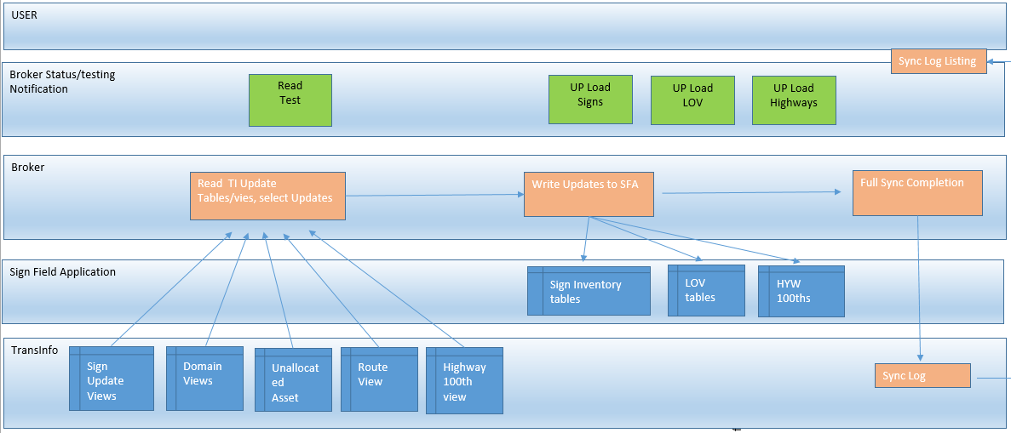
Fig 3.

At the completion of sign update process the Broker will initiate the LOV update process. The SFA has 3 types of LOV tables.

- A typical LOV table with 1 or 2 attributes. This type of LOV table is maintained in TransInfo as a domain.

Table 4. SFA Typical LOV tables:

SFA LOV table | TransInfo Domain
tblActions | Actions (new)
tblCauses | Causes (new)
tblDirection | General Direction (existing)
tblDistircitLkup | Tbd
tblDistricts | *contains districts and Regions
tblHighways | Tbd
tblMajorMinor | *2 unrelated fields – not needed
tblMilePostPrefixes | Tbd not needed?
tblRourtesInterstate | Tbd not needed?
tblRouteState | Tbd not needed
tblRouteUS | Tbd not needed
tblSheeting | SIGN_SHEETING
tblSides | XSP
tblSignFacing | 3 fields – not needed ?
tblSubstrate | SIGN_SBSTR

- The second type of SFA LOV table have 3 or more attribute fields As described in the table below the multi attribute LOV value sets as either a un-located asset or will be derived from the TransInfo route grouped .

Table 5.
SFA LOV table | TransInfo Source
tblSOIDefaultValues | TBD
tblStandardSignGraphics | TBD 3 fields – one is a client file location
tblStandardSigns | Un located Asset
tblSupports | Un located Asset

The multi-attribute LOV attribute sets; tlbStandardSigns and tbleSupports are maintained in TI as un-located assets SIGN (standard signs) and SUPP (Supports). In turn these assets are used to create the corresponding TransInfo domains STAND_SIGN and SIGN_SUPP. Upon update of any of the un-located attributes a trigger updates the corresponding TransInfo domain as described in fig x.
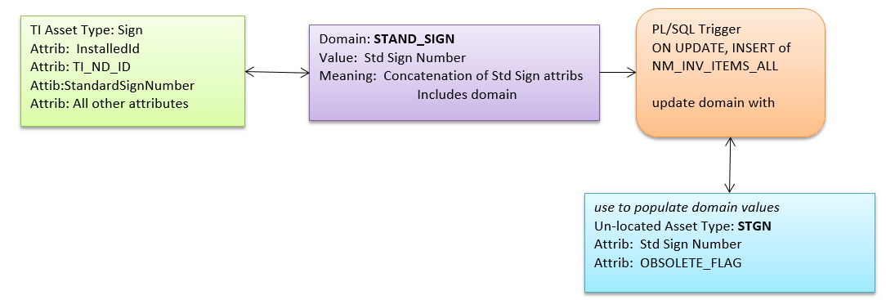

Fig 4.

Note the addition of the obsolete flag attribute to be used in sign maintenance workflow to prevent use of obsolete domain values.

- The 3rd type of SFA LOV tables are highway related and are updated from the TransInfo linear route tables or views

Table 6. SFA Highway related LOV tables:

SFA LOV table | TransInfo Source
tblHighwayEA | Highway group
tblHWYLkup | Highway group

Insert / Update Highway 100’s data from TransInfo

The Highway 100’s data is a listing of ODOT Highway routes with a mile point offset and x,y coordinate every .01 miles. This file contains the following fields.

HWY GPS Data (MP Hundredths)
GIS_PRC_DT
HWYNUMB
LAT
LONGTD
MLGE_TYP
MP
OVLP_CD
RDWY_ID
RDWY_TYP
Crew
LAST_UPDT_DT

This data is used by the SFA to establish the milepost location of a sign installation. Highway data is maintained on an ongoing bases and Highway realignments as a result of construction are modified as soon as possible.

(is there a process that dictates update latency?)

It has been determined that network updates will be provided to the SFA via a highway 100’s file on a monthly bases. A batch process recreates the view XSFA_HIGWAY_100 the first day of every month. However, the Broker simply reads the update date of the first record. If the update has occurred sense the date of the last successful sync, the Broker will sync the Highway 100’s file with SFA. This will allow for the update of the Highway 100’s data between cycles in needed./

The sync process will delete the entire highway segment in the SFA and replace it with the updated segment.

This design will be tested for performances, if it is too slow the update process will delete and replace just extend of the realignment.

Sync Status and Exceptions

Sync Status

The Broker will maintained a date of last successful sync and a date of last interrupted sync. However this data is for user information.

The Broker processes sign data one record at a time. At the conclusion of a successful insert or update of SFA data into TI the broker removes the subject record from the edit table. In the event of a sync interruption, the next sync will simply starts over.

The Sign assets and the Highway 100’s file have SFA update fields. The Broker will evaluate update status and only update record the have not been processed.

The domain updates in TransInfo are low volume. In the event of an interrupted sync process will simply re-update the LOVs on the SFA

At the conclusion of a successful full sync, or failed sync the broker will write the following data to the sync log table:

Table 7.
Sync Date
TI User Name
Windows User Name
Computer Name
Succeeded
Issue
SFA to TI count
TI to SFA Sign count
LOV count
Highway 100 count

    - Exceptions

The exception table is a running history of synchronization actions. This table is made available to TIG as a custom object for reporting.

At the completion of a full sync process an exception listing will be written to an excel file at C:\Sign Log Listings\sync_(syncdate,time) then opened on the client desktop for user review.

Table 8. Exception listing excel format:

Sync Date | TI User Name | Windows User Name | Computer Name | Succeeded | Issue | SFA to TI count | TI to SFA Sign count | LOV count | Highway 100 count

Sync Process Sign Data Update Logic

Data Model

The TI / SFA data integration requires the transformation of data collected and stored in SFA into TransInfo and vice versa. Data transformation, as opposed to a simple extract and load, is required for two reasons:

- SFA collects and manages data at a District level, TransInfo maintains and manages data at a state level. The unique identifier of a sign installation in SFA is created and maintain to insure referential integrity of child assets. This SFA unique identifier is only unique at the district level. This design could not be changed without a costly upgrade in technology and consequently development of a new sign data collection application. Therefor the sync process accommodates and utilizes the existing unique identifier in SFA as well as the TI state-wide unique identifier that is required and automatically created during insertion of a new asset record in TI.

- The SFA data model, which was designed and optimized for field collection, is not well suited for an enterprise level asset inventory management system. Fig 1 below provides a high level description of the SFA and TA and the data flow between the systems.

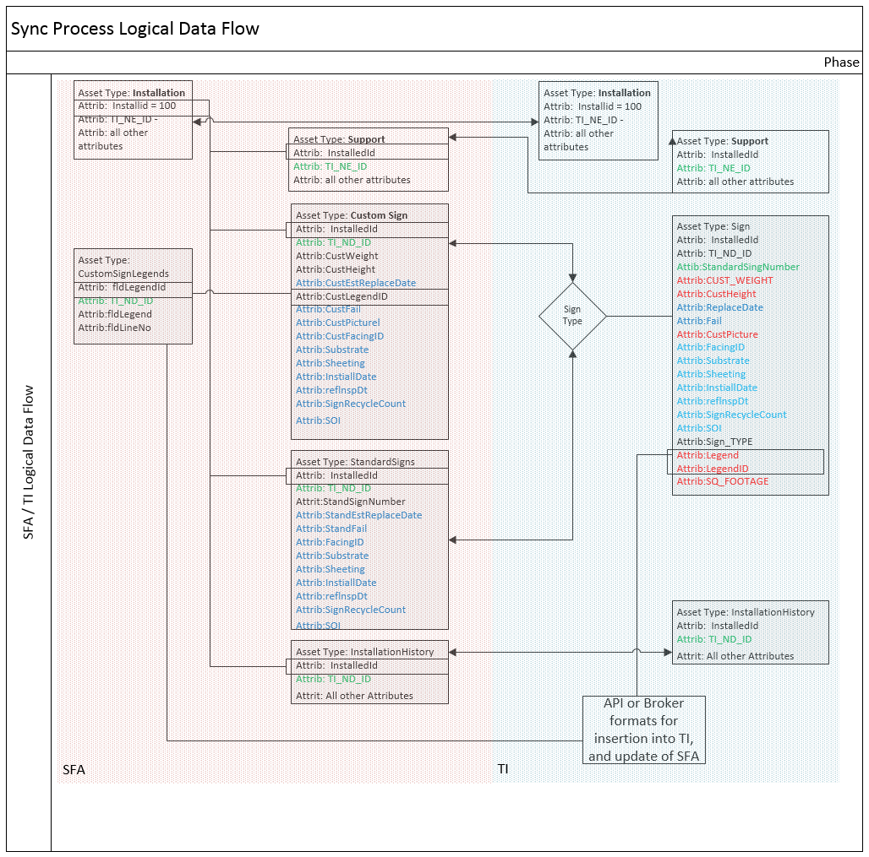

Installation Data Synchronization Logic

As described in fig x, Sync 1 below when a new installation from SFA is synchronized with TI the SFA installation data is inserted into the TI installation asset which automatically creates the NE_ID attribute. The NE_ID is a unique value. The process then updates the SFA Installation asset attribute TI_NE_ID with the NE_ID of the TI installation asset.

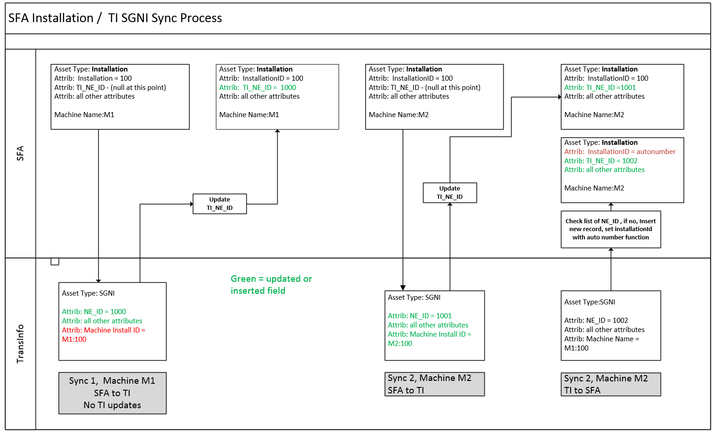

Do we
In the event of a deleted installation in from SFA , the sync process will end date the asset in is then end-date in TI. The asset will be end-dated on the day of synchronization. Upon end-date of an installation all its child assets will be end-dated.

In the event of modification of installation attribution in SFA the rules for update or end-data in TI are as follows:

(TBD)

If an installation is end-dated in TI it will be deleted in SFA.
An update in TI, to include locations results in a updated in SFA
This
The installation fldSide attribute is loaded as SGNI XSP

Joe: Do we need Machine Install ID or not, or rt mp ?

Not to charlotte - The installation fldSide attribute is loaded as SGNI XSP

When TI installation data is synced Sync 2 with the SFA the process checks for a duplicate TI_NE_ID in SFA. The sync process filters assets to be uploaded by the date modified. The check for a duplicate TI_NE_ID will prevent assets downloaded to TI in the same sync event from being reloaded.

The new installation will be inserted into SFA, the InstallationId is set by the native Access autonumber function.

Supports, Maintenance History Synchronization Logic

The sync process begins with installations. This will assure all subsequent supports, sign panels and Maintenance History are associated with the correct Installation in TI. Fig X below describes the process logic for syncing new supports from SFA. This same logic applies to Maintenance History and Panelss This process begins by determining the Installation TI_NE_ID. The Support data is then inserted into the TI SNGU asset. The process then updates the NM_INV_TYPE_GROUPING table and the TI_NE_ID in the SFA Supports table.

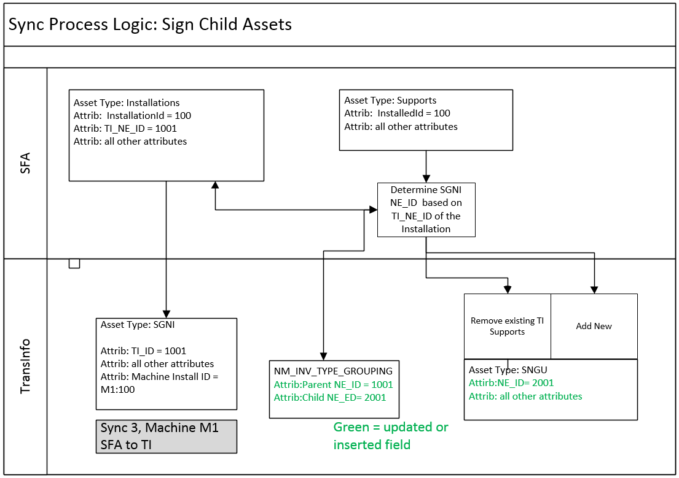

Fig x

In the event of a update to a support asset in SFA the process updates the appropriate support(s) in TI based on the TI_NE_ID of the Installation which is in turn is used to select the NE_ID of the SNGI in the NM_INV_TYPE_GROUPING table. Given knowledge of the NE_ID of the SGNI the process deletes all SGNU child assets of the selected SGNI and replaces them with the supports records from SFA. All of the SGNI child supports have to be deleted because SFI does not uniquely identify child assets. While it is possible to determine which support(s) was modified added or deleted, it is simply more efficient to remove all of the existing supports in TI and replace them. The TI to SFA sync process is essentially the same in reverse.

  - Panels

Panel data in TI is maintained in the SPGN asset. In SFA this data is maintained in three inventory tables: IntalledCoustomSigns, InstalledStantardSings, and CoustomSignLegends. The process (yet to be determined if this occur on Broker on in Oracle) will manage combining this data in the SFA to TI sync, and segregating the data in the TI to SFA sync. The basic update/revision process is the same as described in the previous section. Fig x below describes the custom sign panel data transformation process.

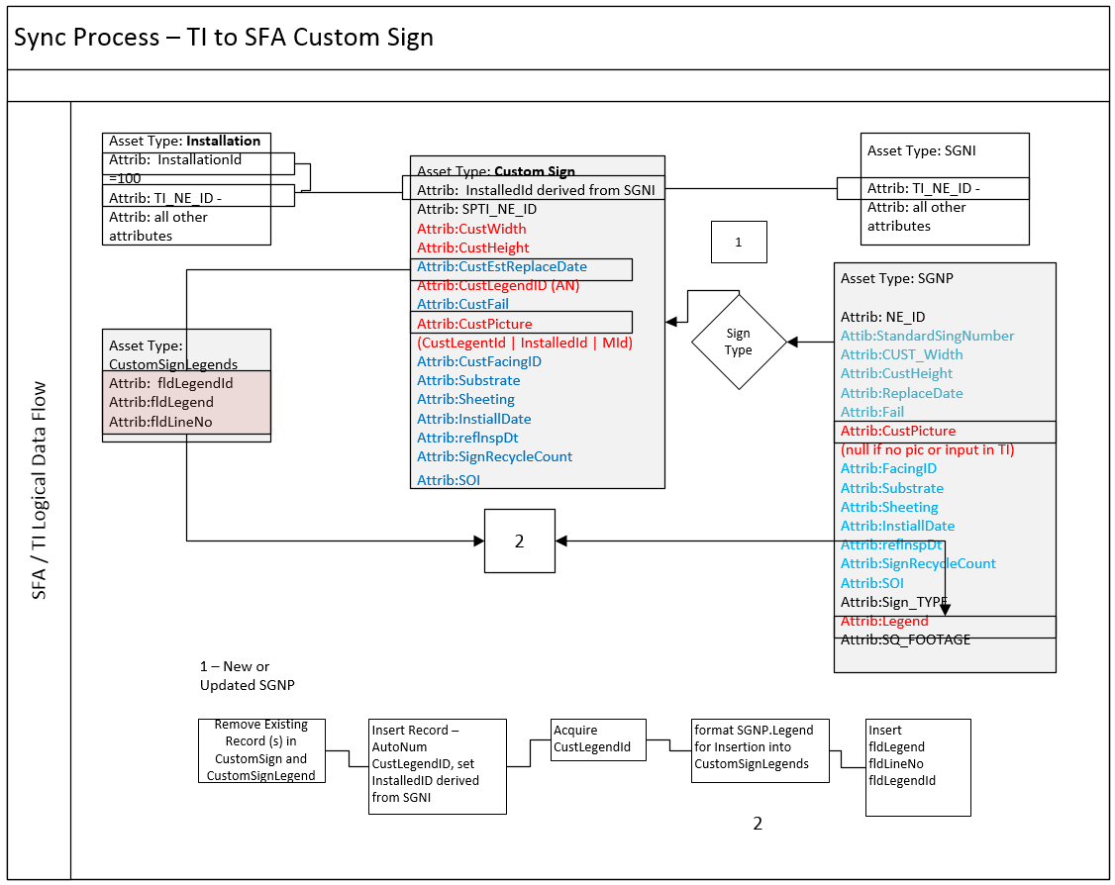

In the SFA to TI sync the process identified as 2 involves concatenating multi-line (multi-record) panel legends into one line useing a “|” delimiter. This record is then inserted into SGNP.LEGEND. The TI to SFA sync is the same in reverse. The data input workflow for legends will have to be developed to insured proper placement of line delimiters.

Jason I see the filed size on legend is 255 – is that truly the size limit or to you control the size in the form and if so what is it?

Testing and Data Migration

Testing

In order to develop and test the SFA to TI integration process the initial migration from the SFA to TI required export of sign inventory tables (see fig x above) from each signdate.mdb from the district server, a single instance of the signclient.mdb, and a pre-sync version of signdata.mdb from all of the district Toughbook data collection units.

We can’t tell from the edit tables what they did. It would be nice if we could get the sign crews to document the updates. . Otherwise for testing we will have to mimic all maintence operations

- TI to SFA Test Use Cases:

- Add new installation, supports, standard sign, custom sign
- Delete an installation
- Add a support, standard sign, custom sign
- Add a support
- Add a standard sign
- Add a custom sign
- Delete a support, standard sign, custom sign
- Delete a support
- Delete a standard sign
- Delete a custom sign

- Interruption Testing

- Post end-date

- Domain – LOV Testing

- Deletions, addition, modification to each of the following LOV tables

SFA LOV table | TransInfo Domain
tblActions | Actions (new)
tblCauses | Causes (new)
tblDirection | General Direction (existing)
tblDistircitLkup | Tbd
tblDistricts | *contains districts and Regions
tblHighways | Tbd
tblMajorMinor | *2 unrelated fields – not needed
tblMilePostPrefixes | Tbd not needed?
tblRourtesInterstate | Tbd not needed?
tblRouteState | Tbd not needed
tblRouteUS | Tbd not needed
tblSheeting | Sheeting (new)
tblSides | XSP
tblSignFacing | 3 fields – not needed ?
tblSubstrate | Tbd

- LOV rebuild on District Server

- Highway 100’s
- Route LOV’s
- Toughbook Rebuild

Design Approach
The process Bentley Systems uses to create a software design document is to first gather system requirements. The system is then broken down into a process flow. The software design is then documented to follow the process flow each component of the software is detailed.

The process automation components have been designed using a number of techniques to facilitate agreement and communication among each of the involved parties. The system process flow is recorded with the use of ‘swim lane’ diagrams. Swim lane diagrams allow the software designer to identify the components and processes required by the new software. A good description of swim lane diagrams can be found at: http://en.wikipedia.org/wiki/Swim_lane. Iterations of the swim lane diagram allow the software designer to modify the planned process to optimize it.

With the process clearly identified, the software designer can detail the process with further swim lanes as required and detail the software design to implement the process.

Bentley Systems has had extensive discussion with ODOT staff during the development of the process automation components specification. The result of that and subsequent design work is a swim Lane Diagram shown in Appendix II and discussed below.

The result is this document which should contain enough detail for ODOT to be sure that the software will meet the identified requirements and for a software developer to create and deliver the software to ODOT.

Development Standards
The Sign Maintenance Broker will be developed using standards defined by Bentley Systems’ Exor Custom Development Code Custodian so as to be suitable for submission into the Bentley Systems Source Code Repository. In general, this means using standard package headers, a naming convention, placing procedures and functions into packages and laying out the install package in the prescribed pattern.

Sign Maintenance Broker should be able to be installed by calling SQL scripts if at all possible and should not rely on users needing to enter Sign Maintenance Broker the application to configure it.

Scripts should be provided to completely uninstall the software if this is ever required.

TransInfo Data Structures

Design Assumptions

The following assumptions have been made to facilitate this design: Foundational Component Description

Foundation Components
Some components of the software are used many times and are not explicitly depicted in the swim lane diagram but are referenced by other components.

Foundation Components required by for SFA synchronization with TransInfo are documented here and will be constructed as part of the development by Bentley as part of the TransInfo project.

Asset and Network Data
The SFA sync process will use asset and network data stored within TransInfo. Refer to the COTS Data Dictionary document for detail.

Asset Maintenance Forms
Asset Maintenance forms are standard components

Network Maintenance Forms
Network Maintenance forms are standard components

Roles
TransInfo users allowed to view or create sign data in TransInfo will be assigned the TI_APPROLE_SIGN_USER. This role will be associated with all sign asset types.

TransInfo Sync APIs

Will be added when completed

Security

Deliverables
The following will be produced as part of the development effort to support the software described above

Scripts

Documentation
Documentation is required to:

Summary
A number of components are required to complete integration of DFMS and TransInfo.

The design documented above has been produced by Bentley Systems. It will be used to confirm with ODOT that the appropriate components will be produced and will be used by a Bentley Systems developer to create software that will provided all the inputs, functions and outcomes required of the integration between DFMS and TransInfo.

